**UI UX Final Project Card Sorting Techniques**

Card sorting is a UX research technique in which study participants arrange individual labels printed on notecards into groups based on standards that make sense to them. This approach helps to develop an information architecture that adheres to users' expectations by revealing the organizational structure of the domain knowledge of the target audience. There are two types of card sorting:

**1. Closed Card Sorting:**

In a closed card sorting experiment, subjects are instructed to arrange the cards according to preset categories using labels made by the researchers. Information must only be aligned with pre-existing categories for participants to participate. The effectiveness of the material's support by an existing category system may be evaluated using this card sorting technique, even if it does not reveal how individuals conceive issues.

The step-by-step process followed for the closed card sorting for our project is as follows

1. The following are the 20 cards used for closed card sorting
   1. 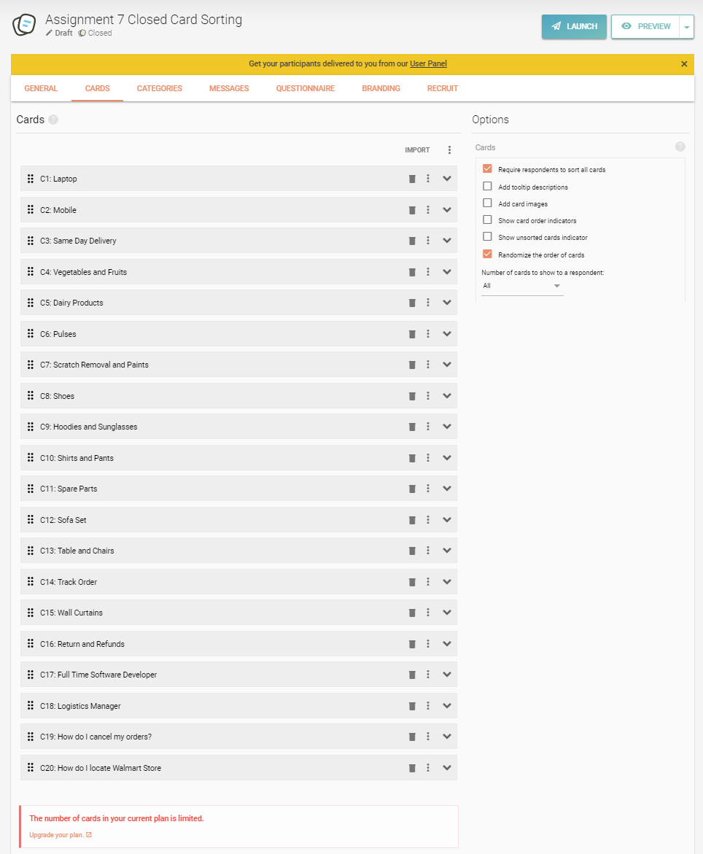
2. The following are the 9 categories used for sorting the cards.
   1. 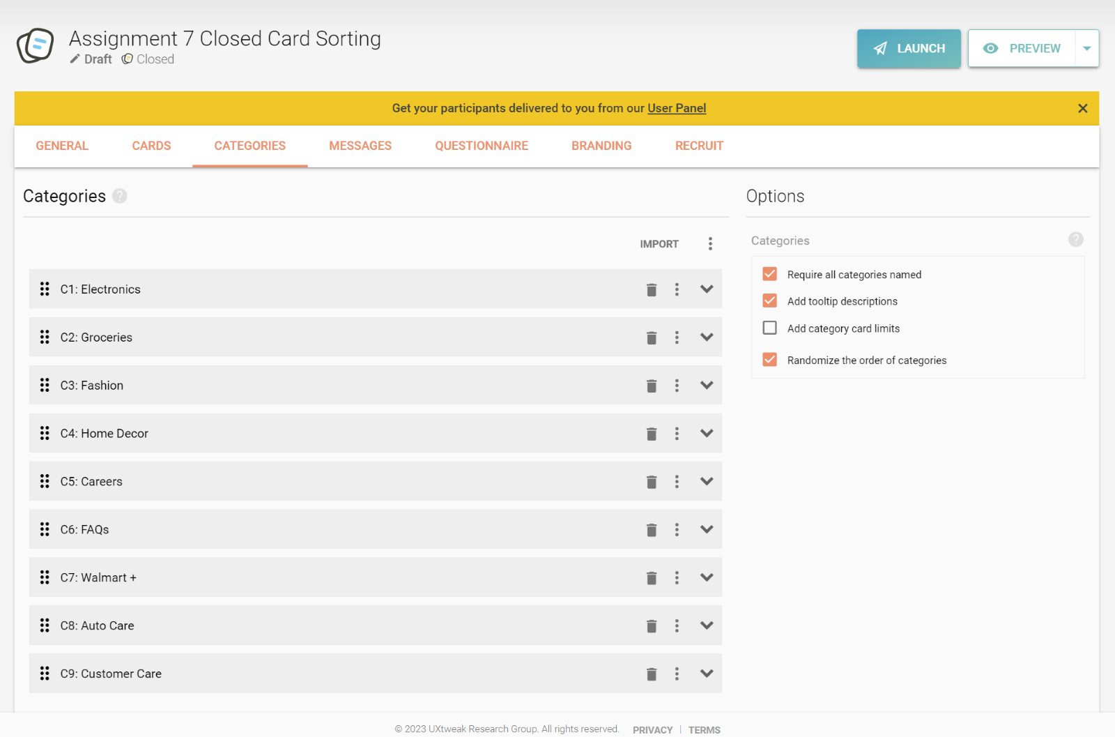
3. We have asked the users 2 questions as post survey feedback
   1. 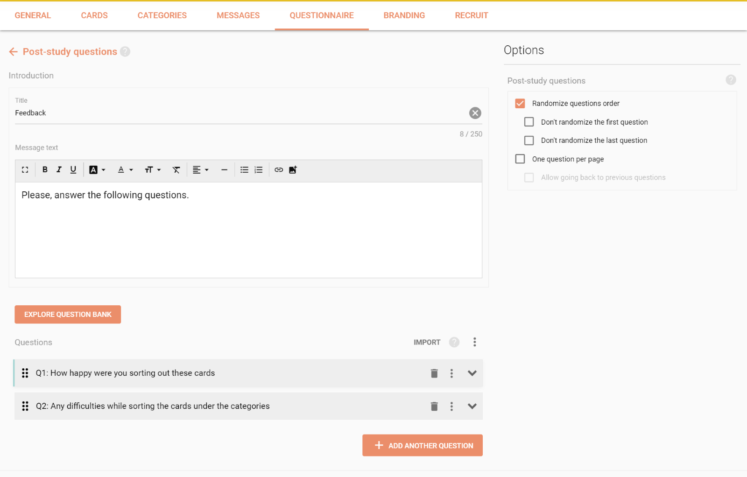
4. Once the survey is done, the page below is launched after selecting the launch option.
   1. 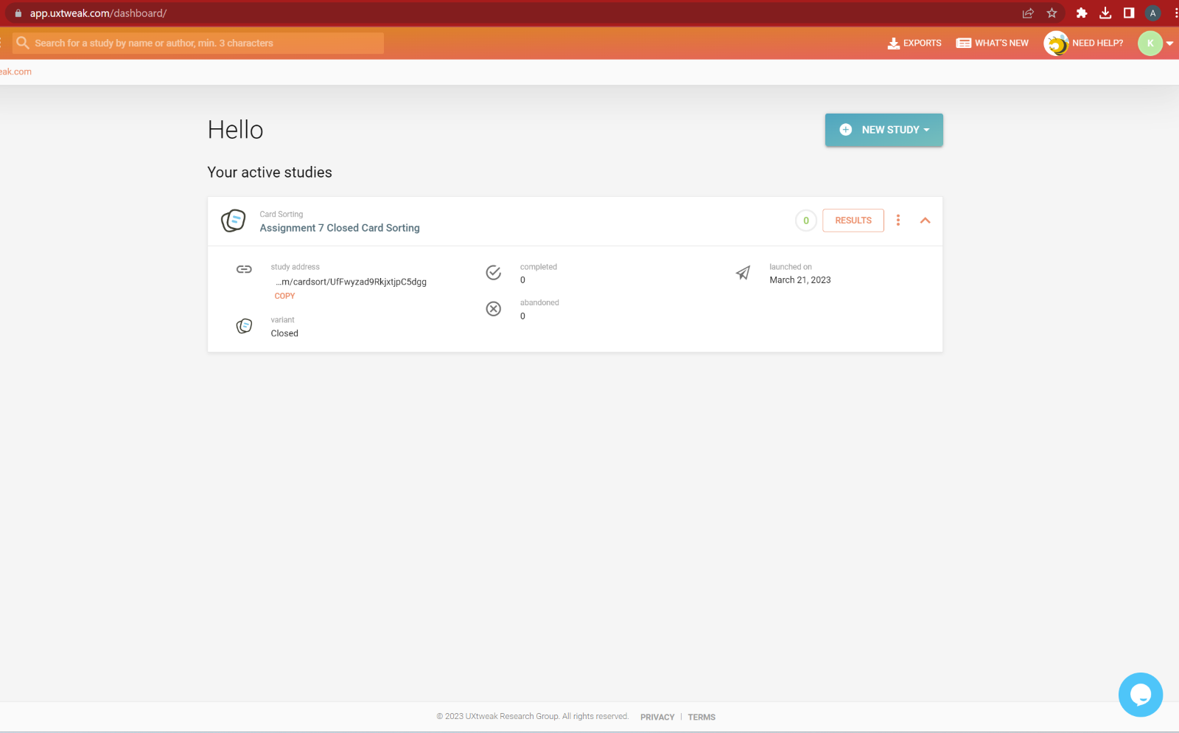
5. The welcome page is as follows
   1. 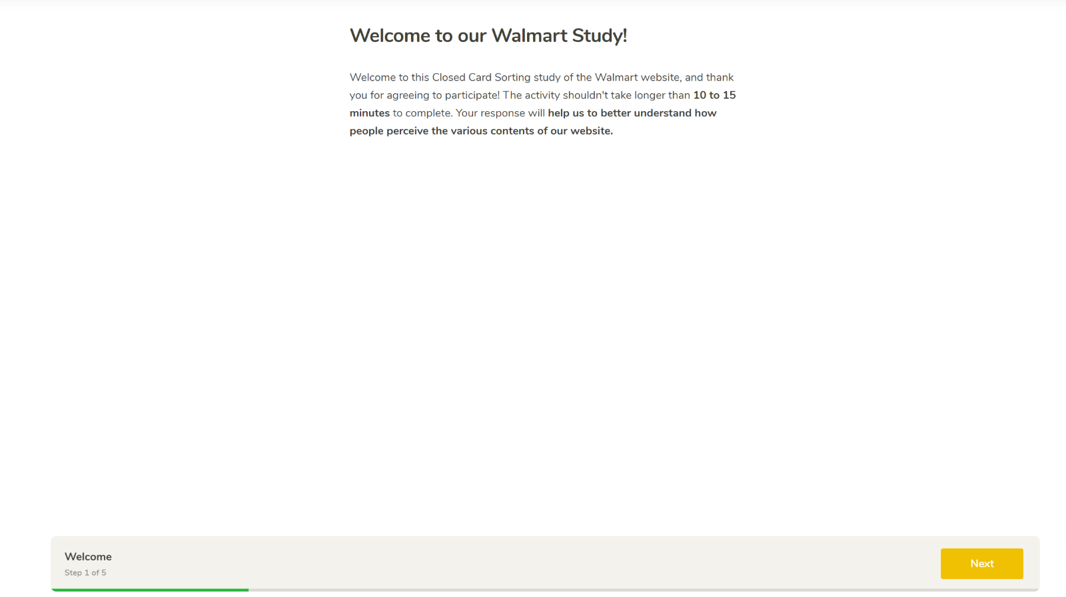
6. The users are provided with instructions on how to continue with the closed card sorting.
   1. 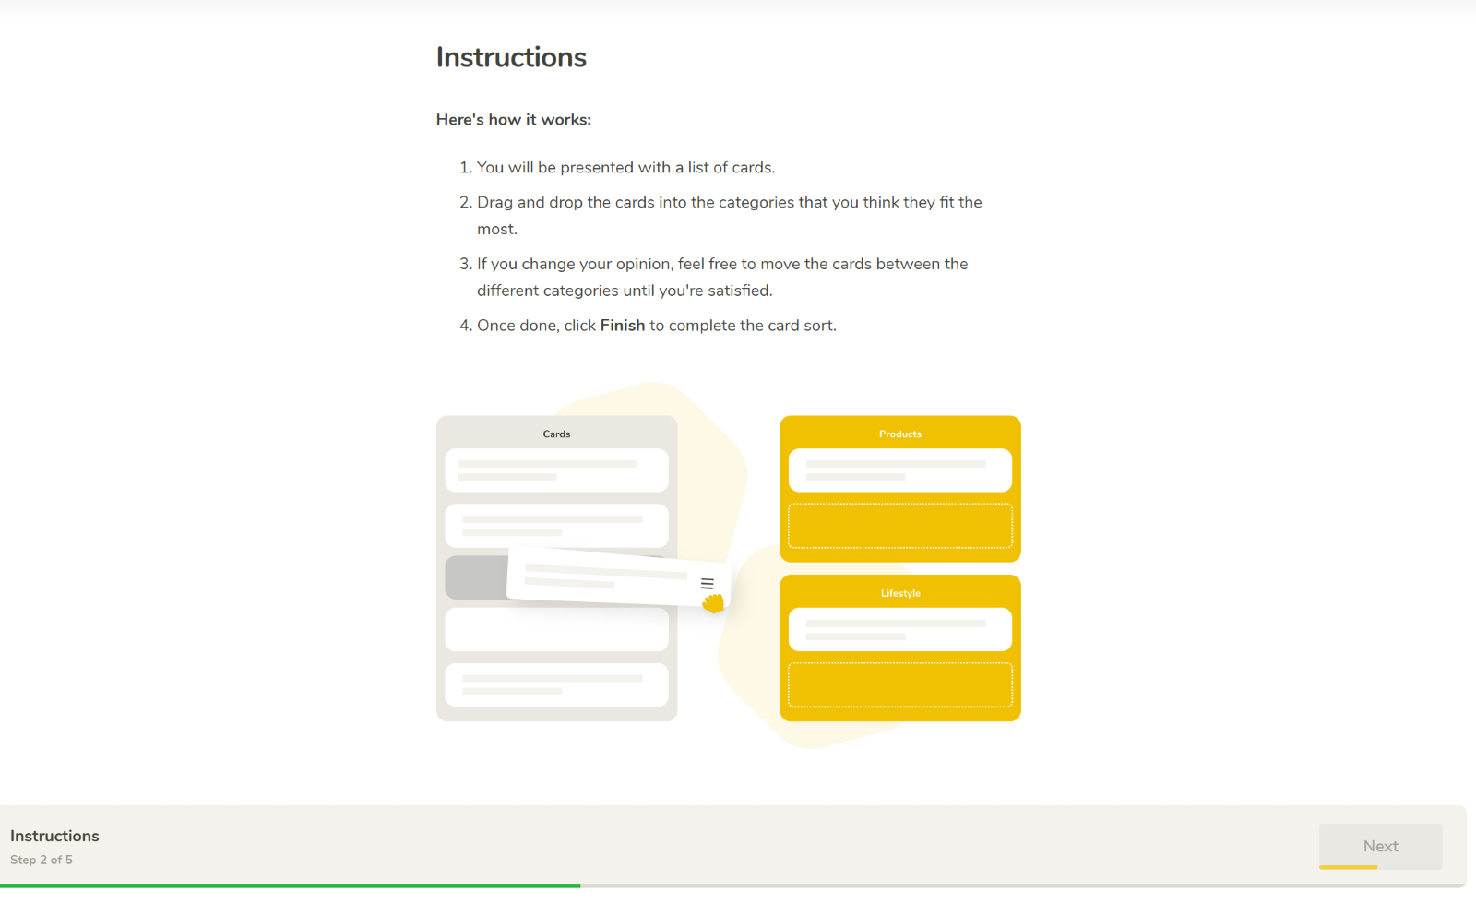
7. The sorting page with all the predefined cards and categories are as follows for the user to proceed with sort.
   1. 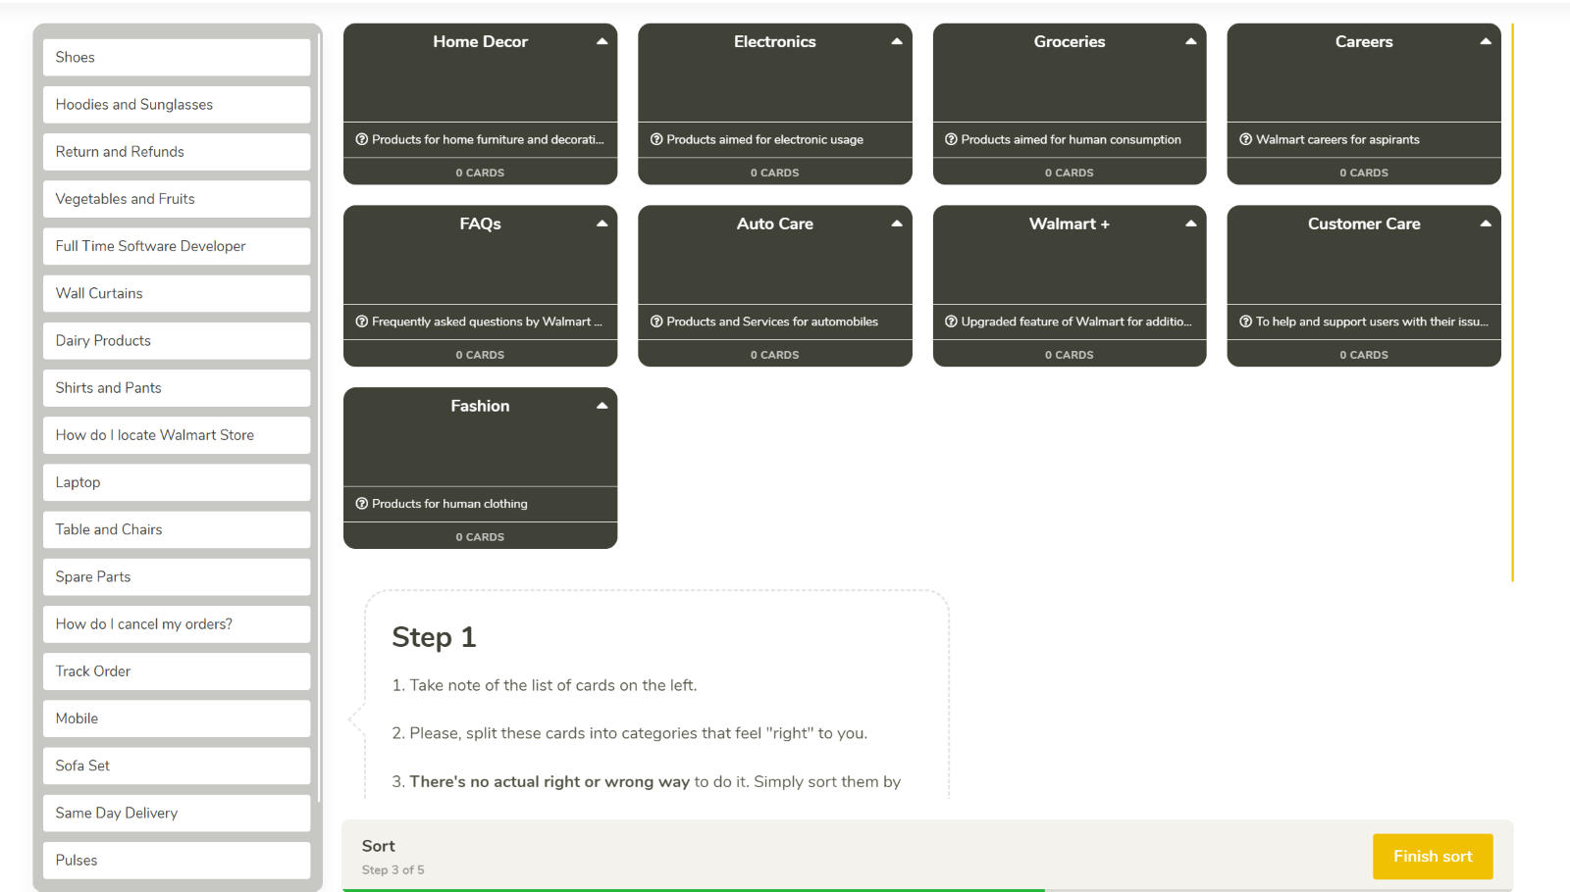
8. The User can sort the cards into the pre-defined categories as follows
   1. 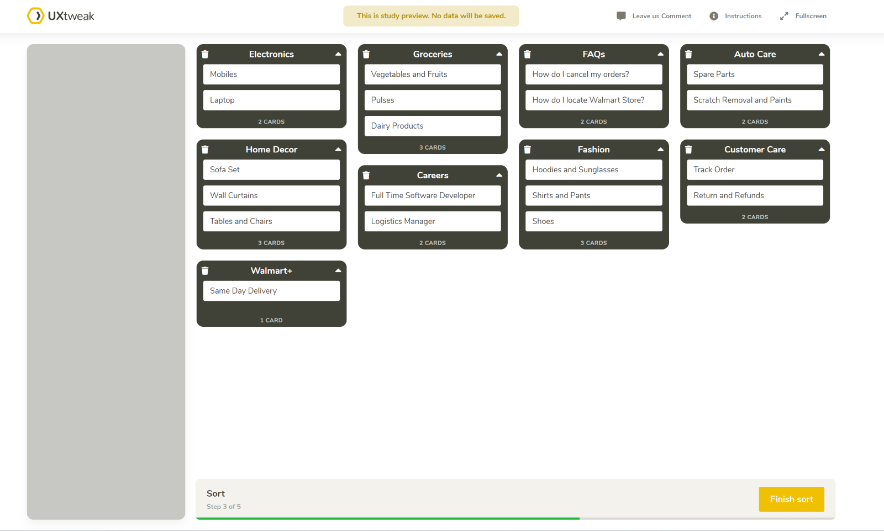
9. The page after the user finishes the sorting
   1. 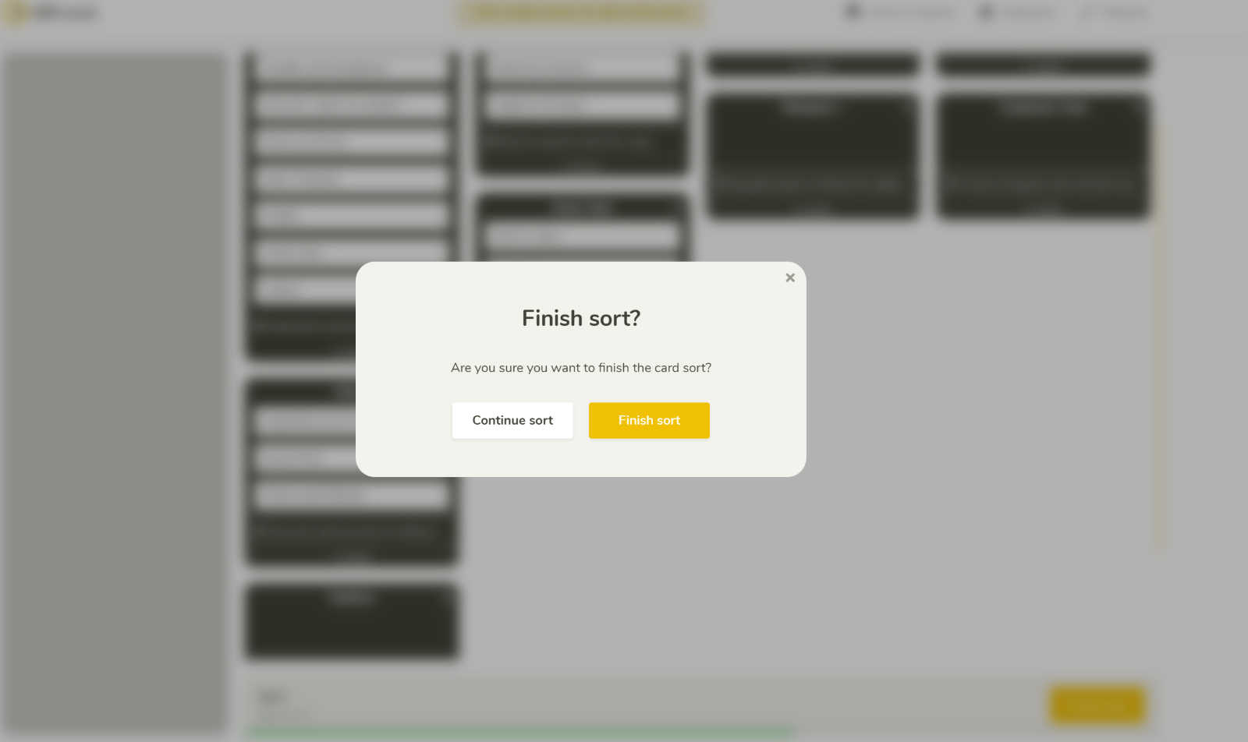
10. The user is provided with 2 post survey questions after his sorting
    1. 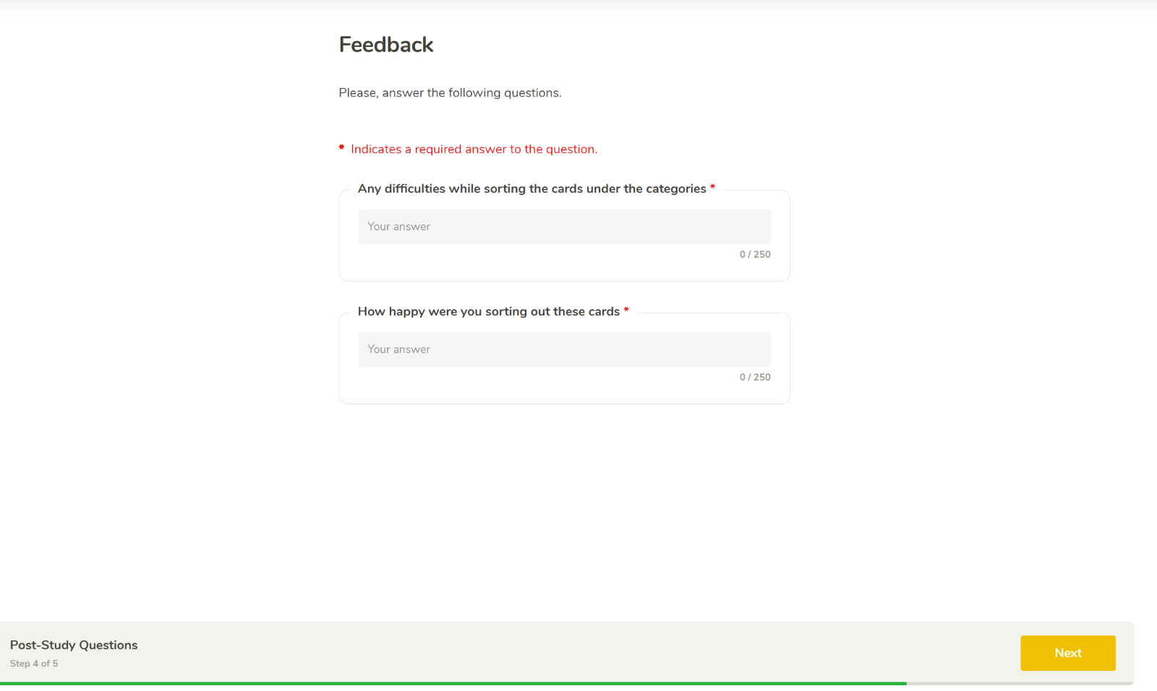
11. A thank you page is presented for the user at the end of the survey
    1. 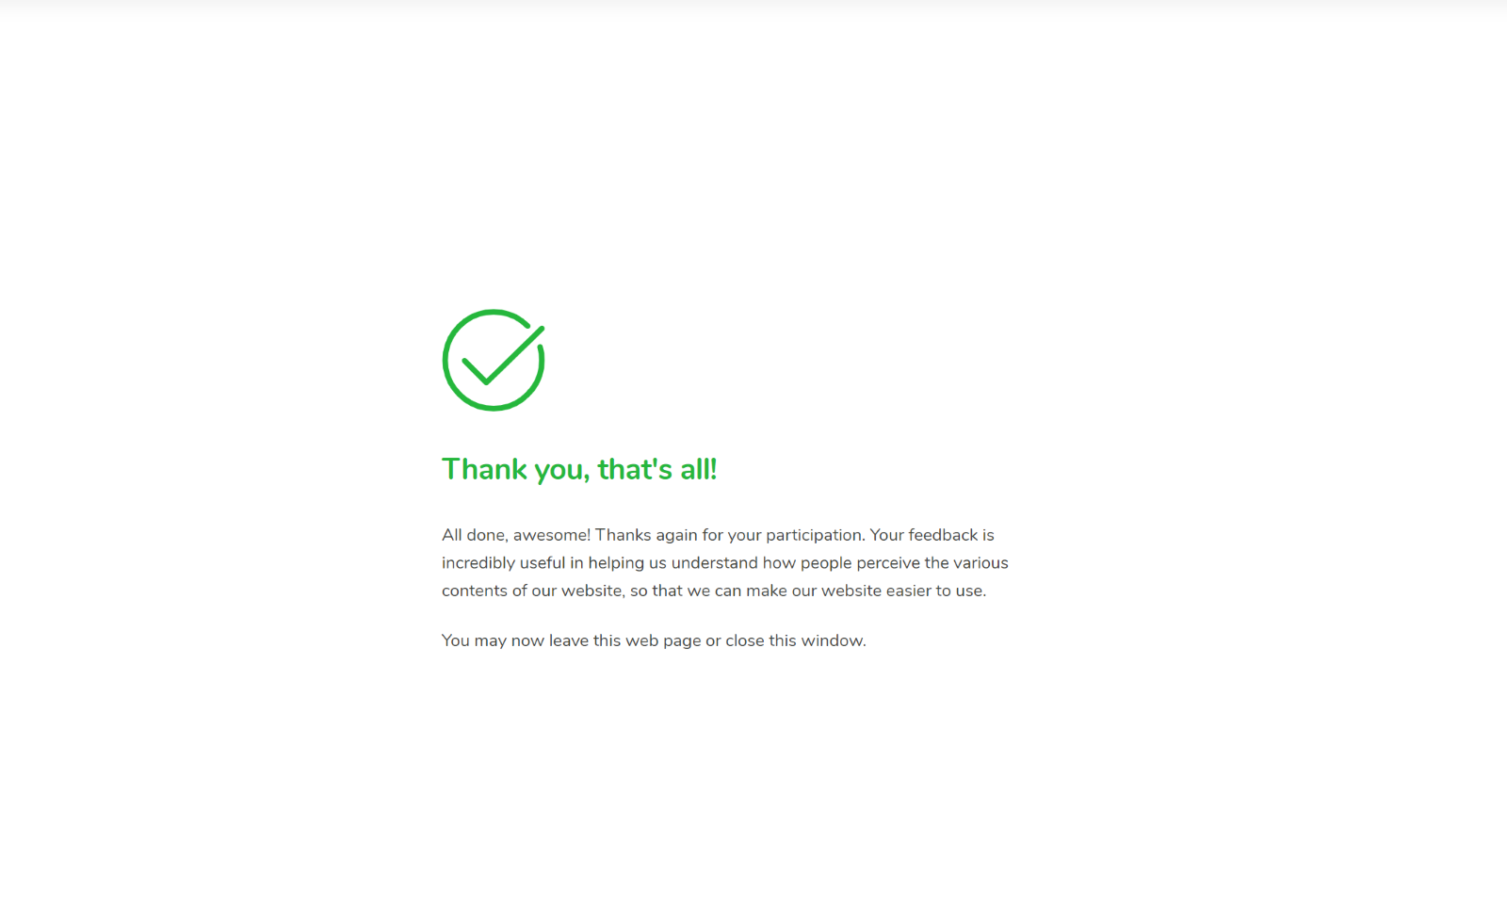
12. The following are the reports of the sorting method after finishing the closed sorting technique.
    1. The questionnaire analysis is as follows for the 3 respondents.
       1. 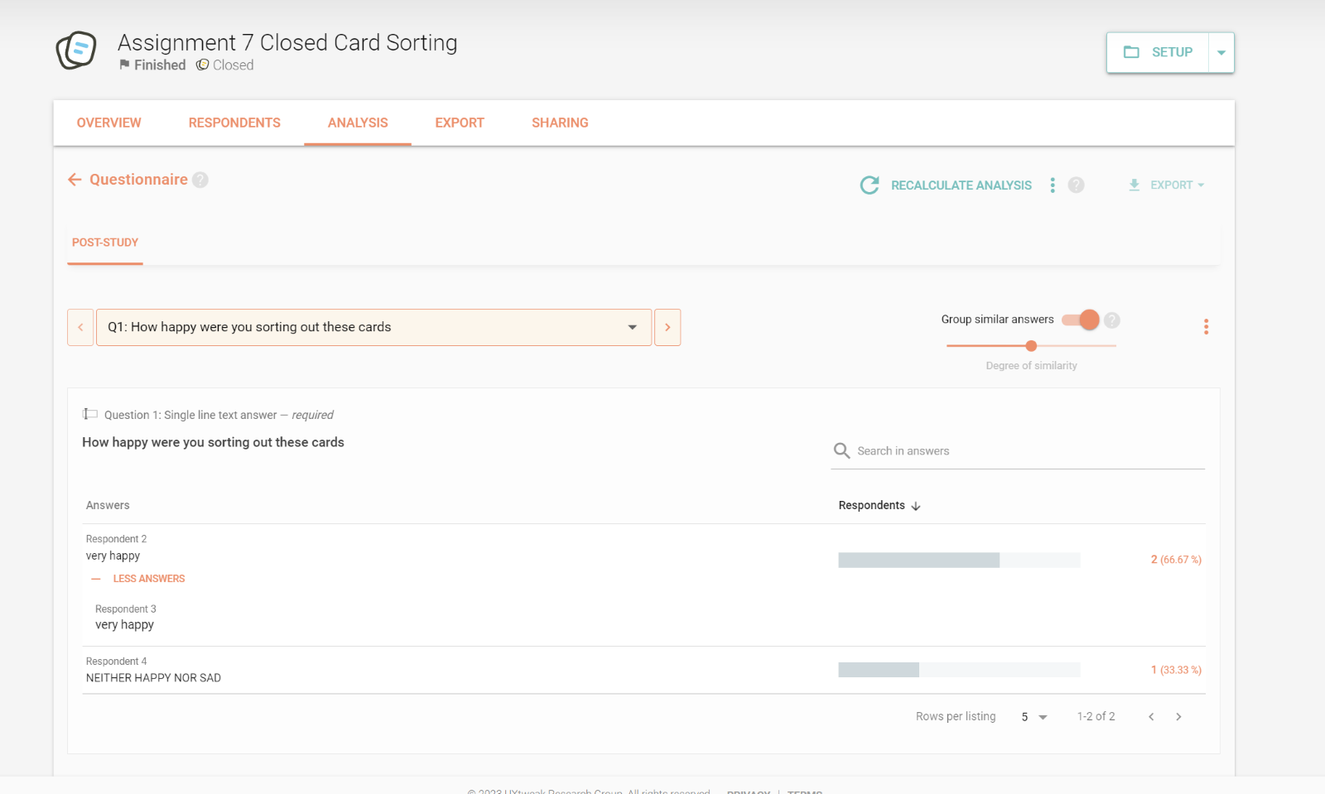 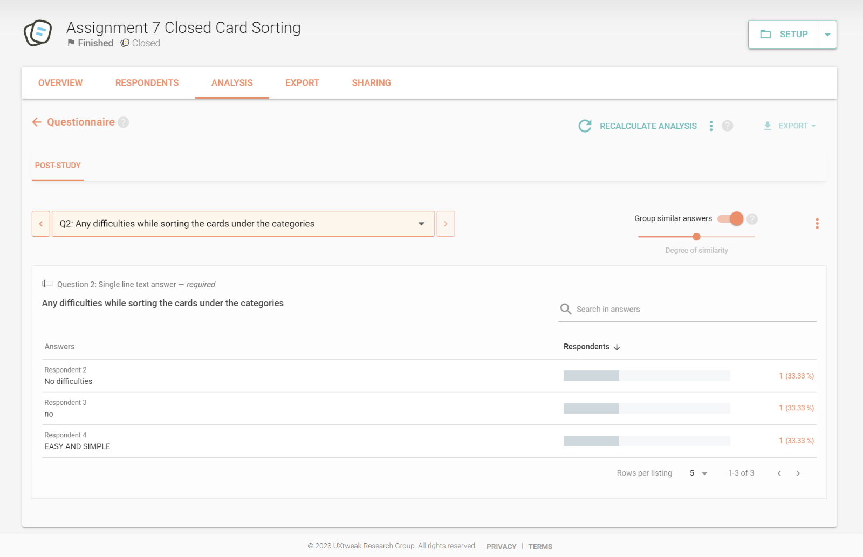
    2. The cards analysis for the 20 cards is as follows for the 3 respondents.
       1. 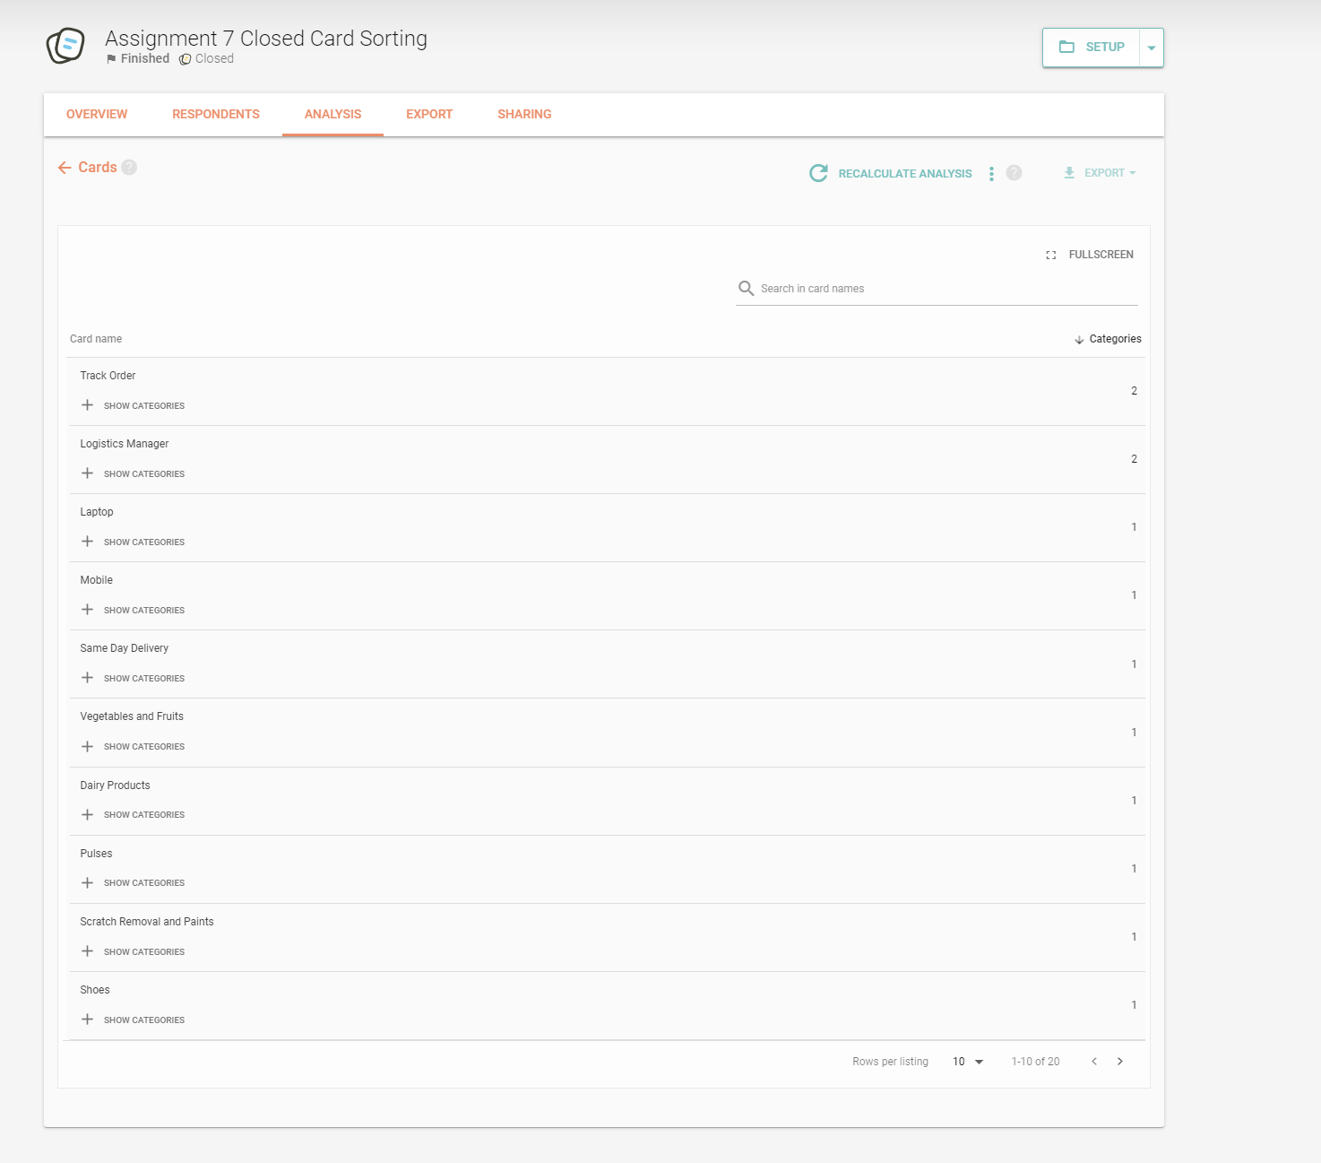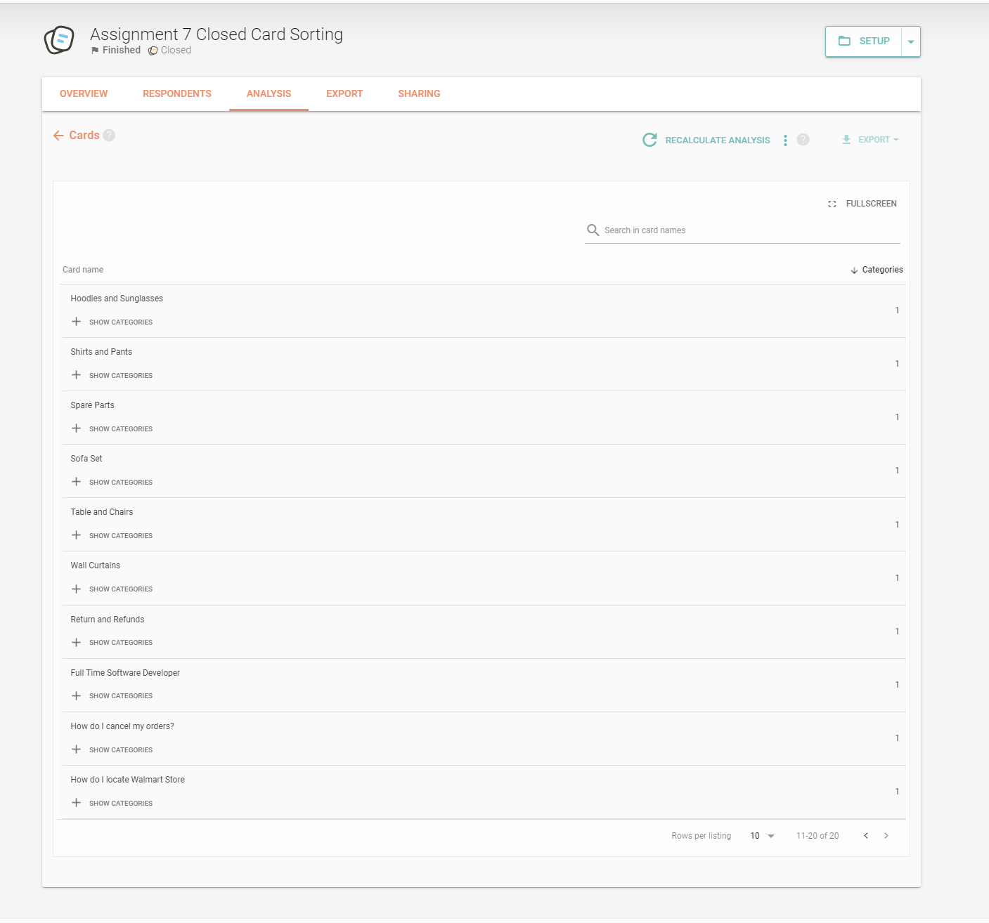
    3. The categories analysis for the 9 categories is as follows for the 3 respondents.
       1. 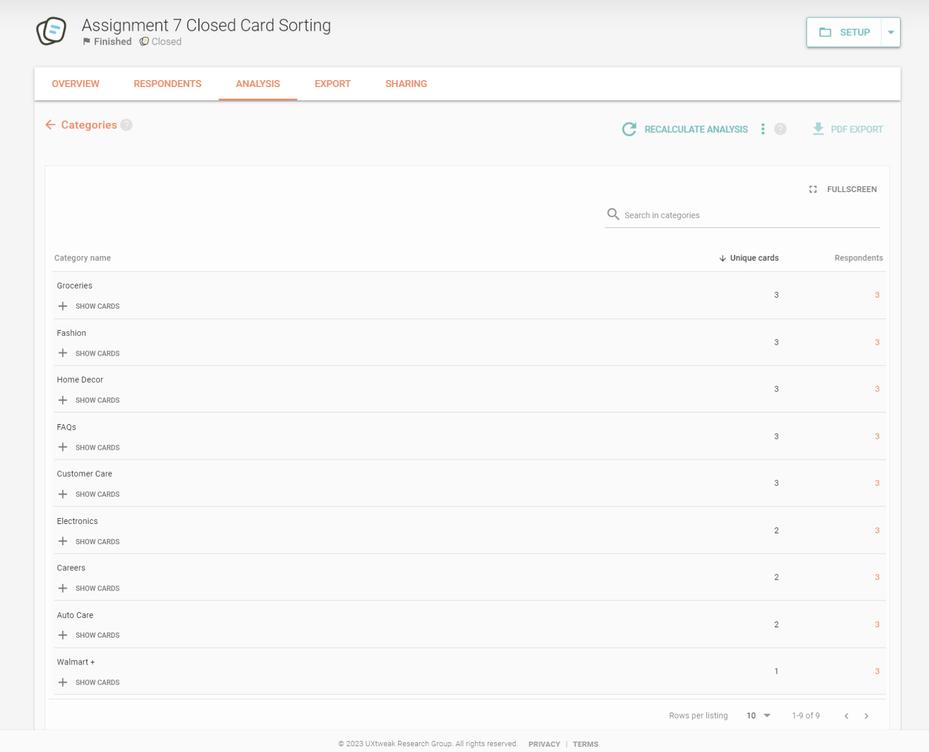
    4. The Result Matrix for the closed card survey is as follows.
       1. 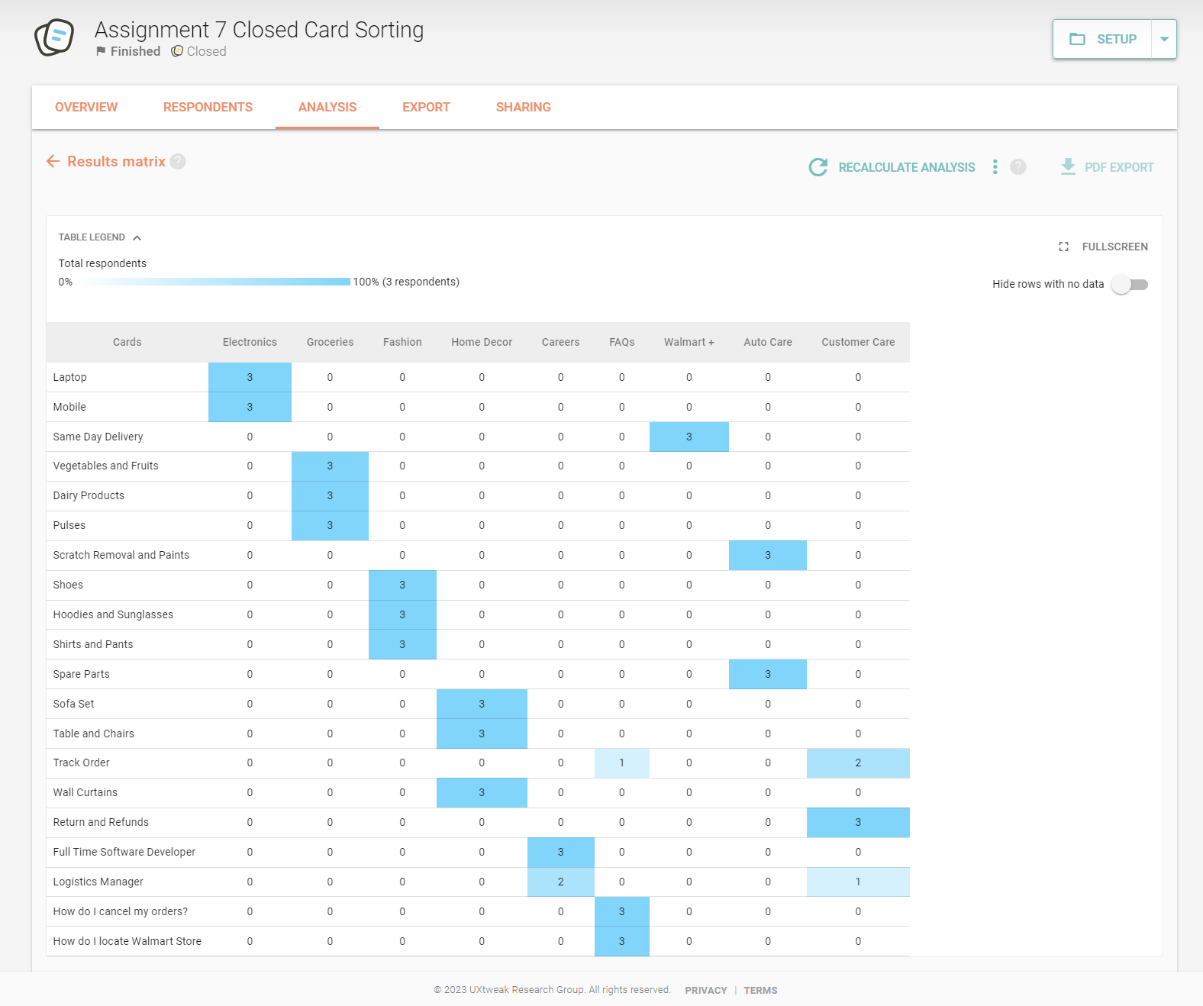
    5. The popular placements matrix for the closed card sorting is as follows
       1. 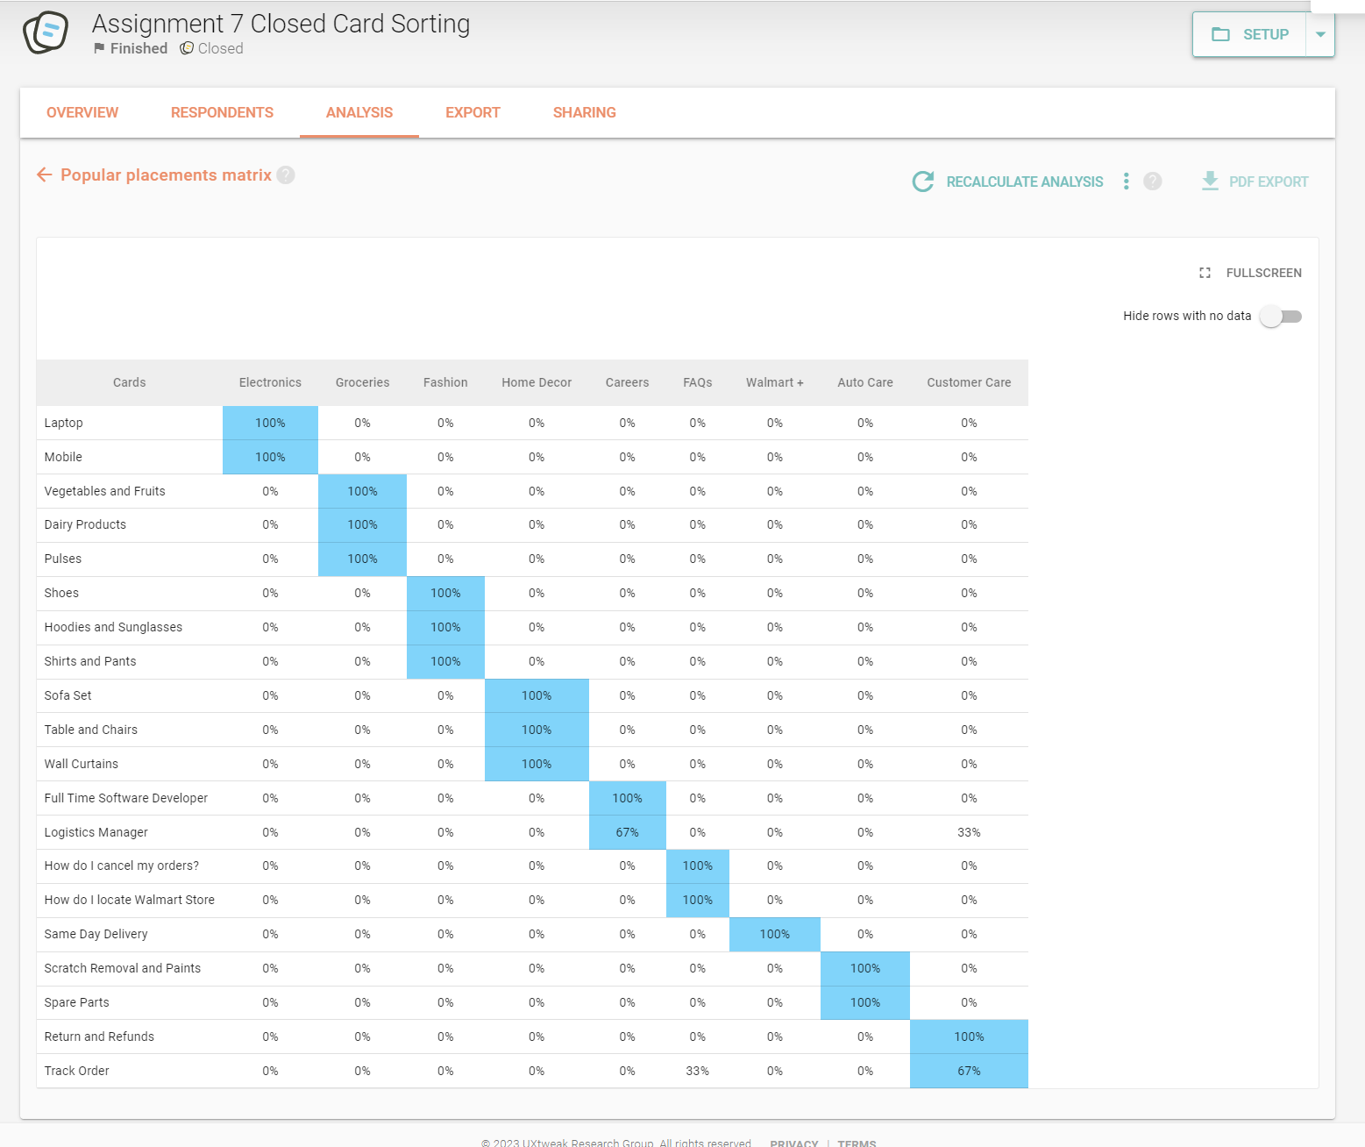

**2. Open Card Sorting:**

Open card sorting entails distributing a stack of topic-filled cards to each participant, asking them to arrange the cards anyway they see suitable. The next step is for the participant to provide labels to the categories they have selected. Participants may be identified without restriction. This method of sorting is useful when we want to build a new website or improve an existing one. By examining the outcomes of card sorting, it is easy to establish whether the website structure that we now have matches how people would organize the same information.

The step-by-step process followed for the open card sorting for our project is as follows. We have used the same 20 cards for the open card sorting as with the closed card sorting.

1. The following page is displayed once the open sorting is launched.
   1. 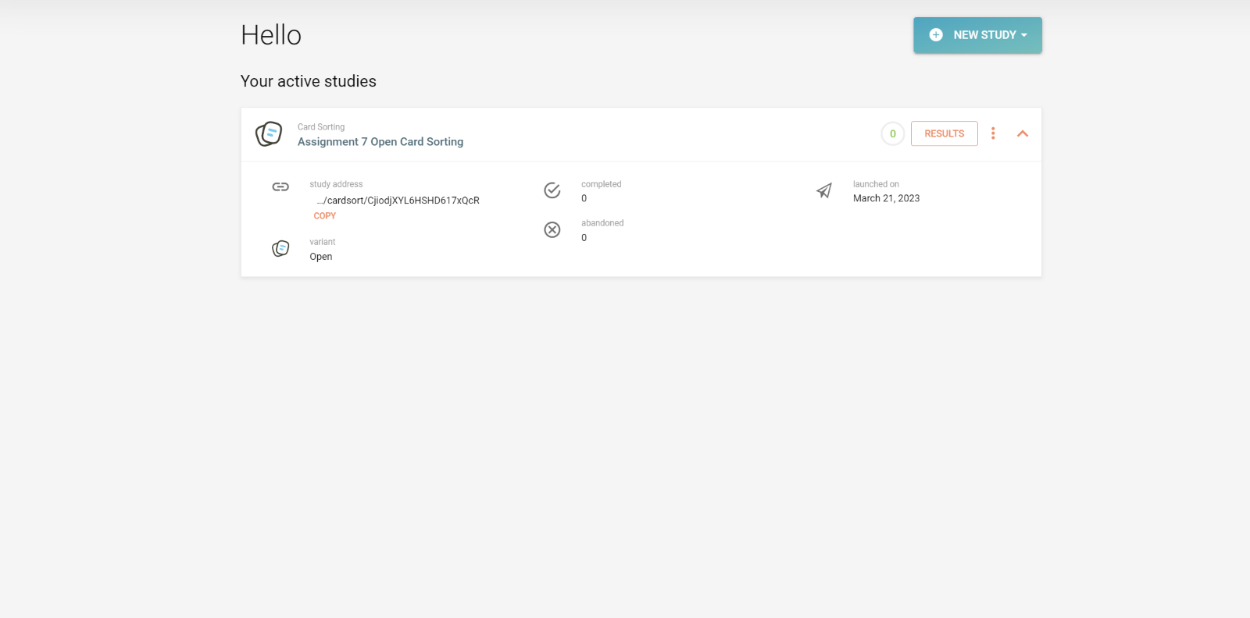
2. A welcome message is displayed to the user before the start of the sorting process.
   1. 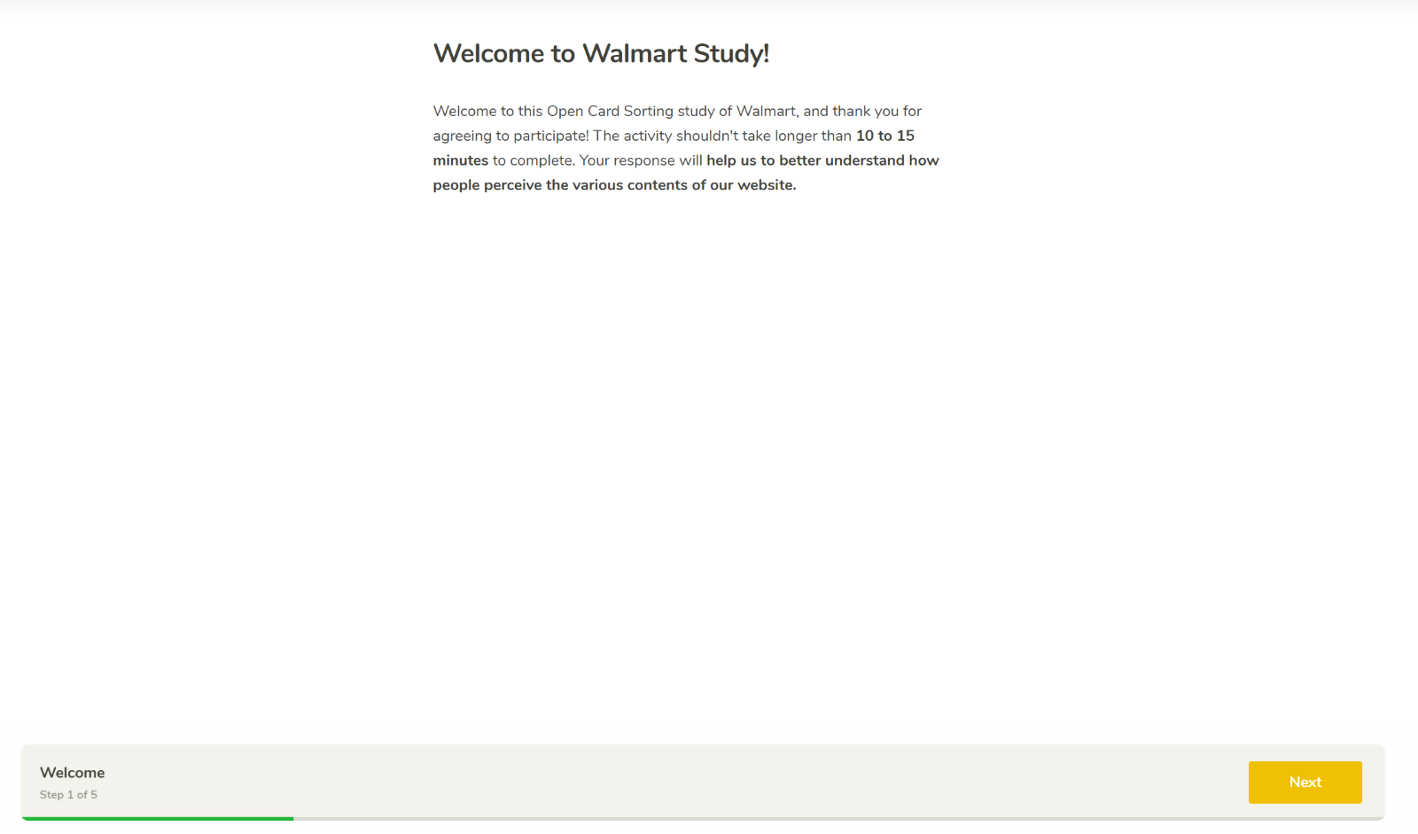
3. The user is provided with instructions on how to proceed with the open card sorting process.
   1. 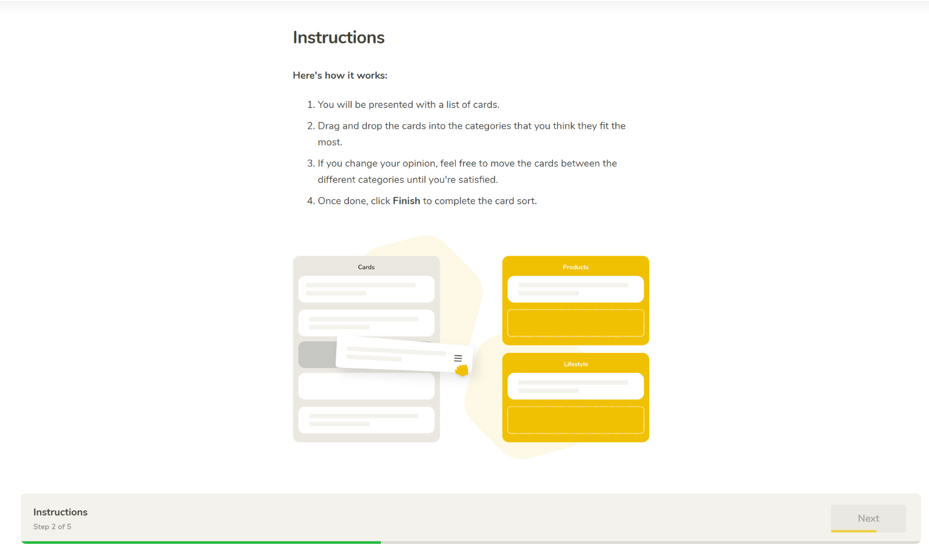
4. All the cards being used are displayed to the user on the following page, where the user is required to create categories of their choice and arrange the cards.
   1. 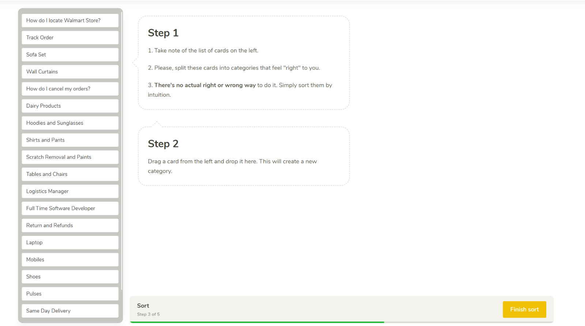
5. The User can sort the cards into user defined categories as shown below
   1. 
6. A confirmation page is displayed after the sorting is completed.
   1. 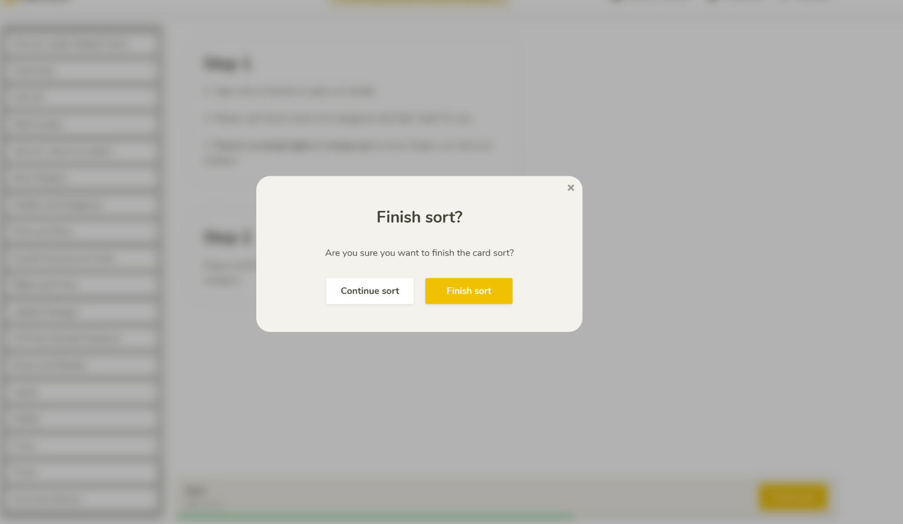
7. The user is provided with 2 post survey feedback questions.
   1. 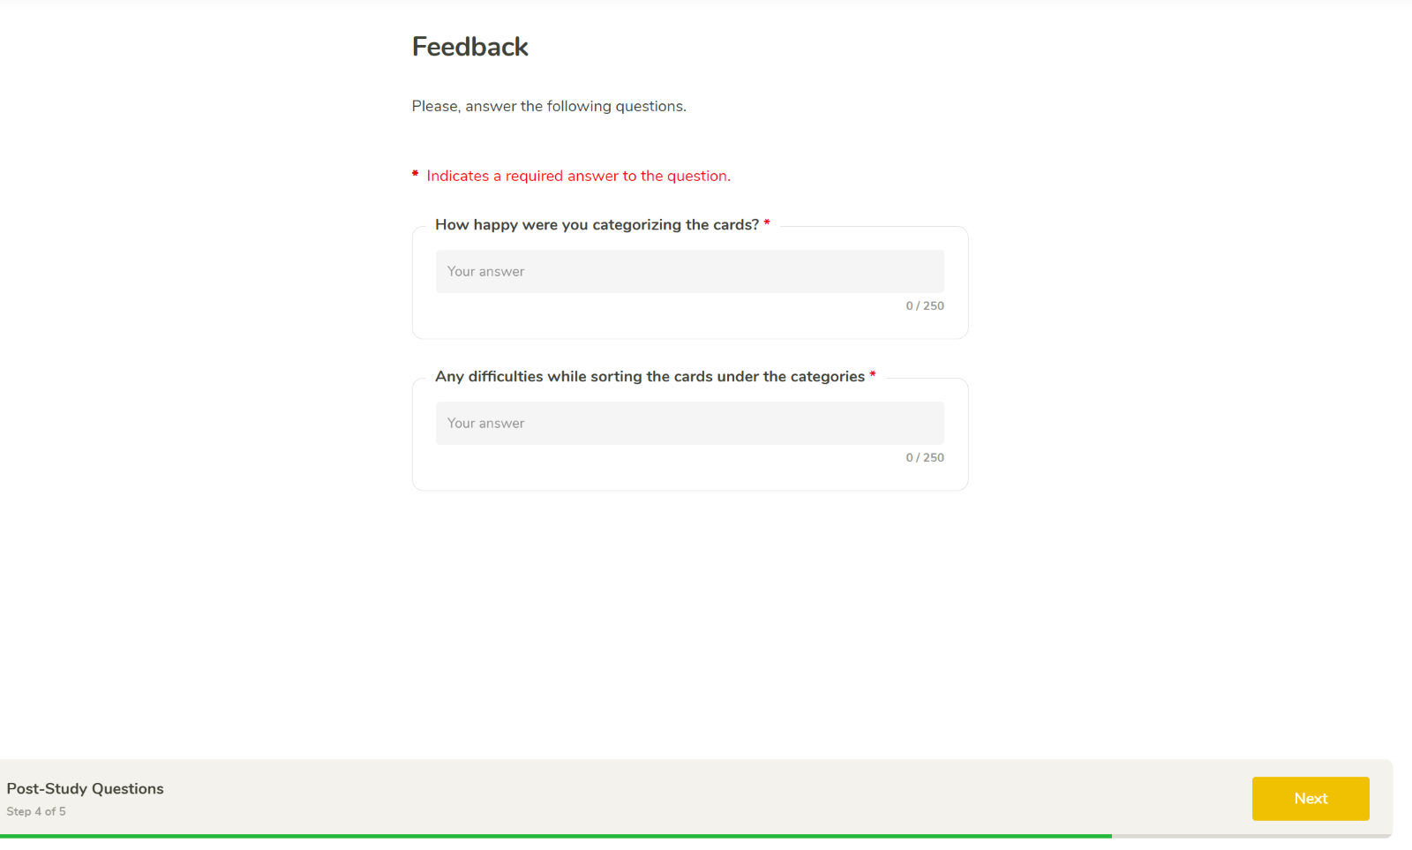
8. A page with a thank you message is displayed to the user.
   1. 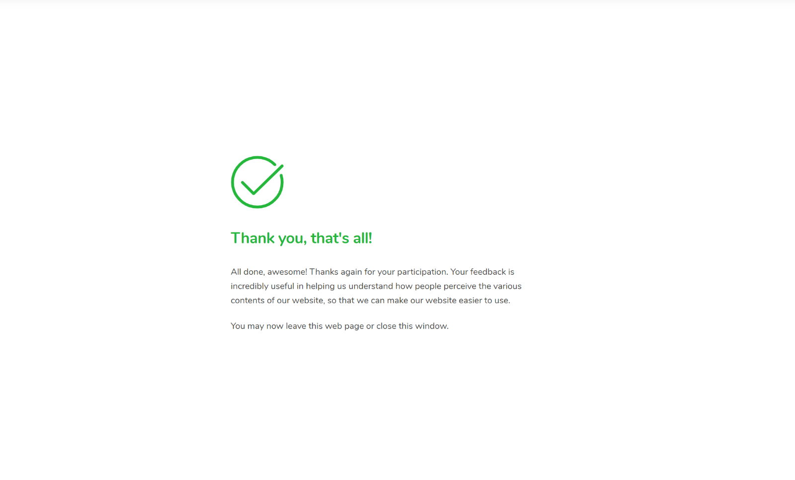
9. The survey is closed, and we then navigate to the reports section.
   1. The overview page of the reports section is as follows, which is its home screen.
      1. 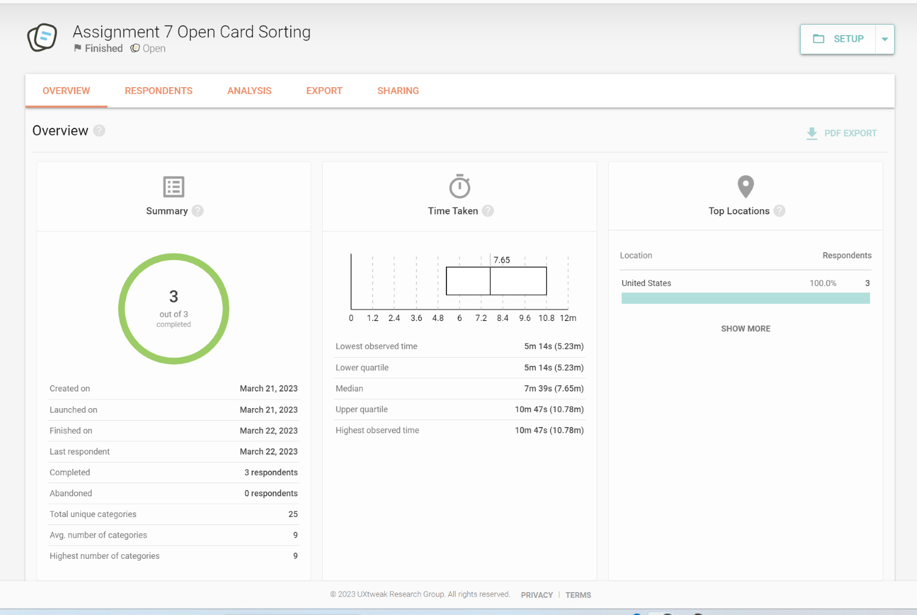
   2. A page showing the respondents is as follows with their details.
      1. 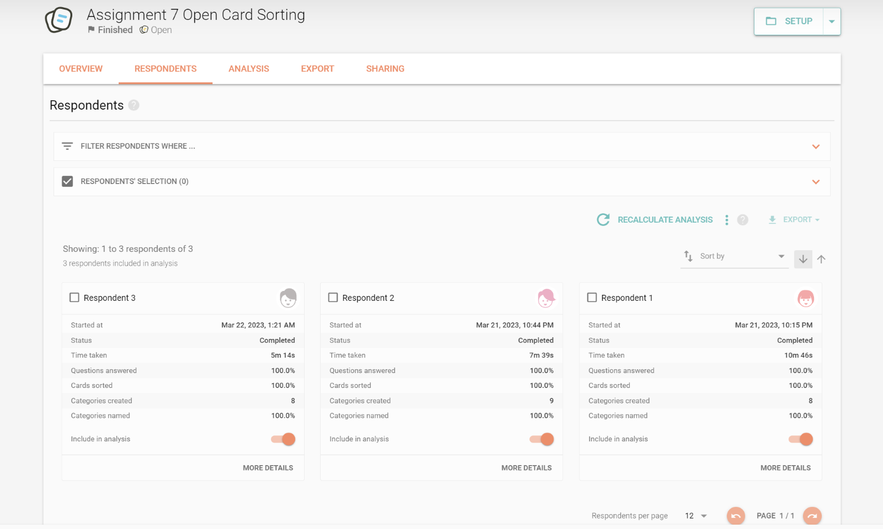
   3. The details of the cards being used in the sorting is displayed in the next 2 images
      1. 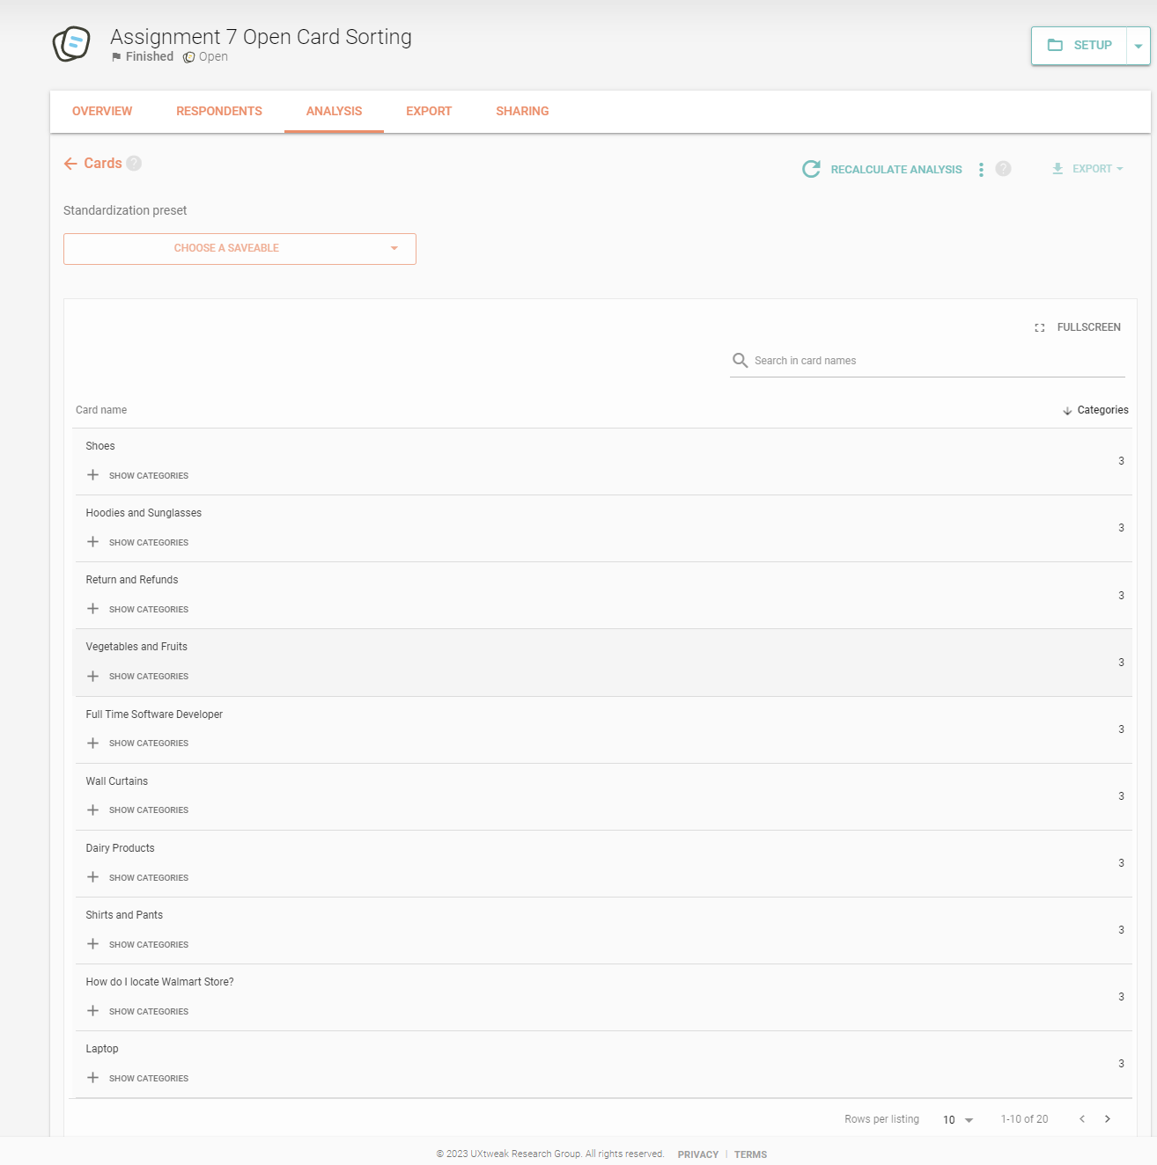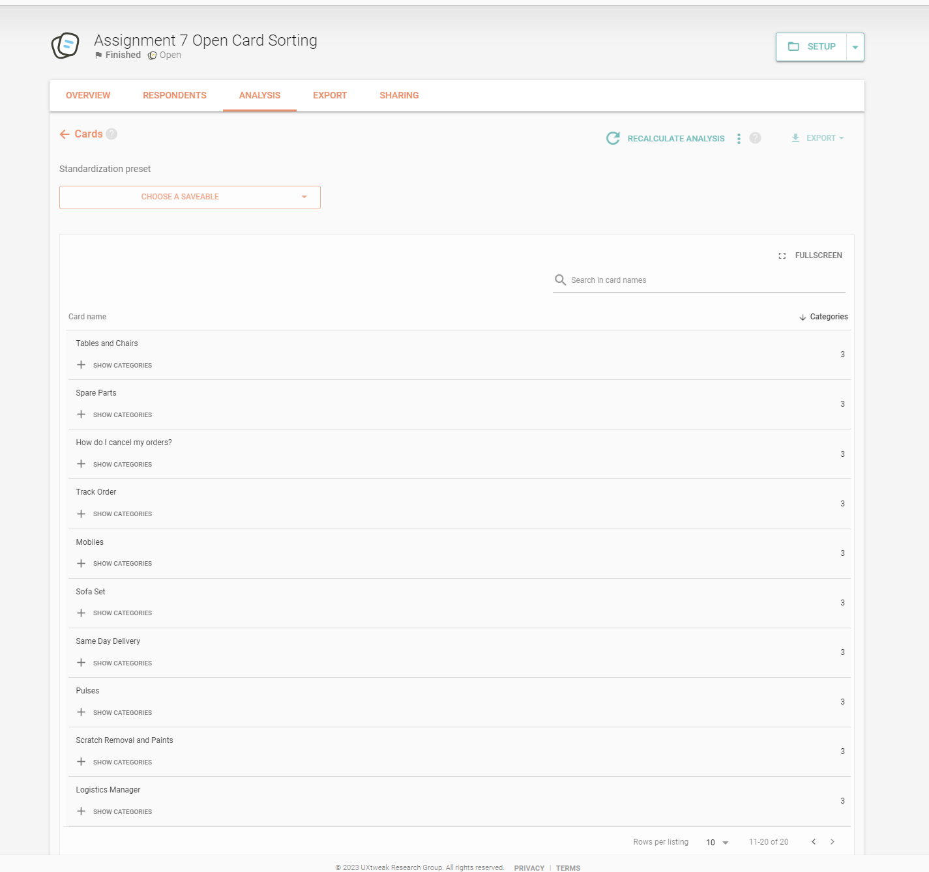
   4. The Dendrogram for the sorting is displayed as 2 types:
      1. The Best Merge method is as follows, which shows how many people agreed with this part of the group.
         1. 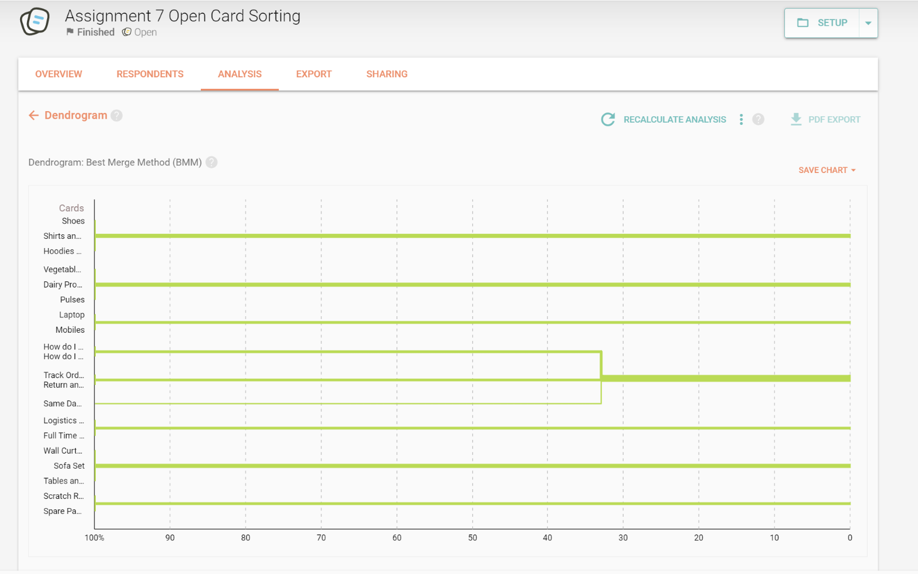
      2. The Actual Agreement Method is as follows which shows how many people agreed with this exact group.
         1. 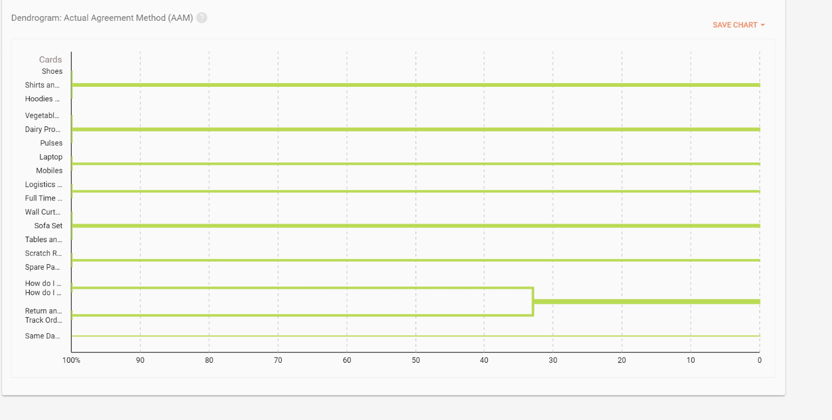
   5. The questionnaire results of the post survey feedback are as follows.
      1. 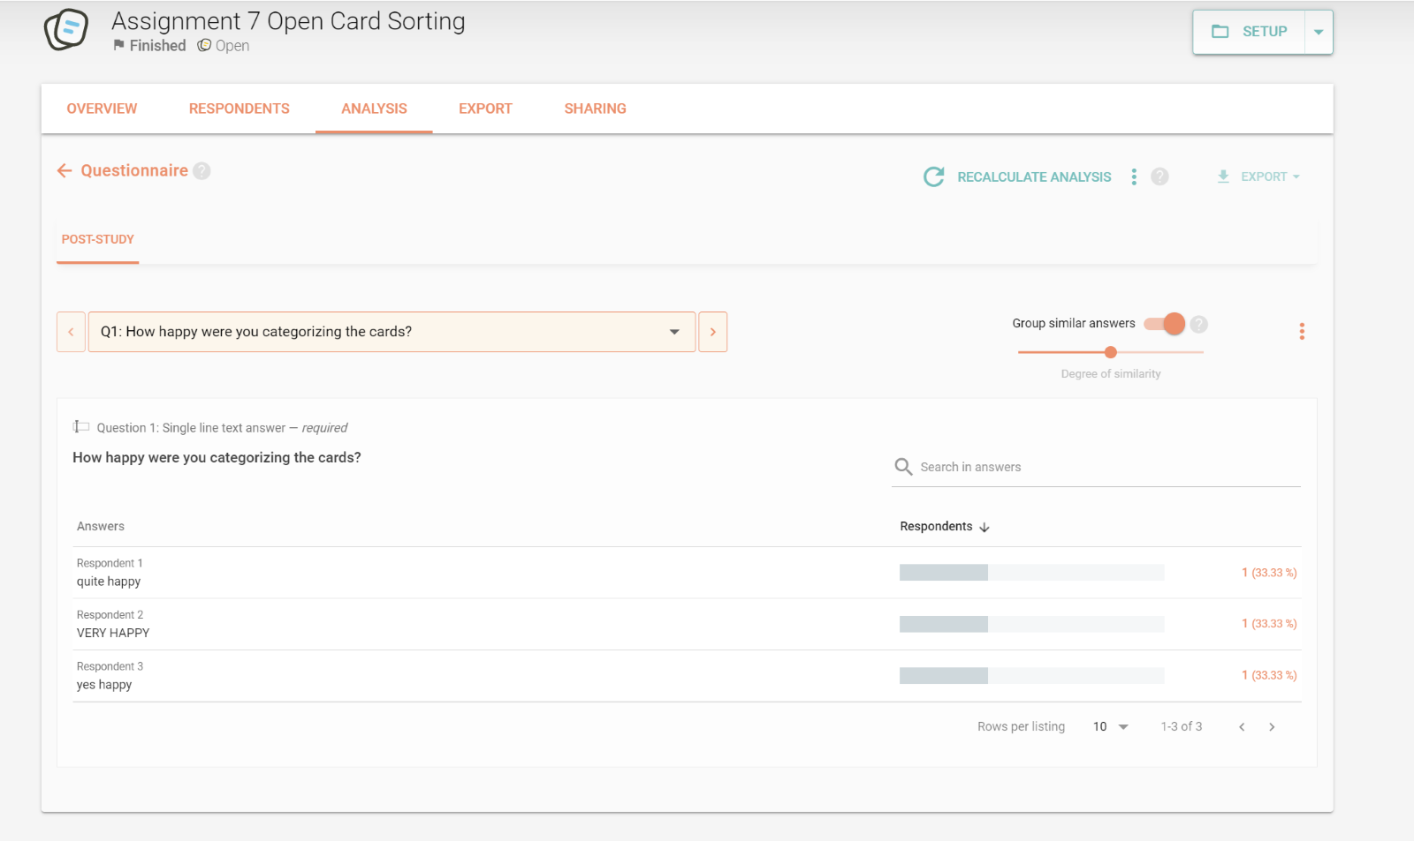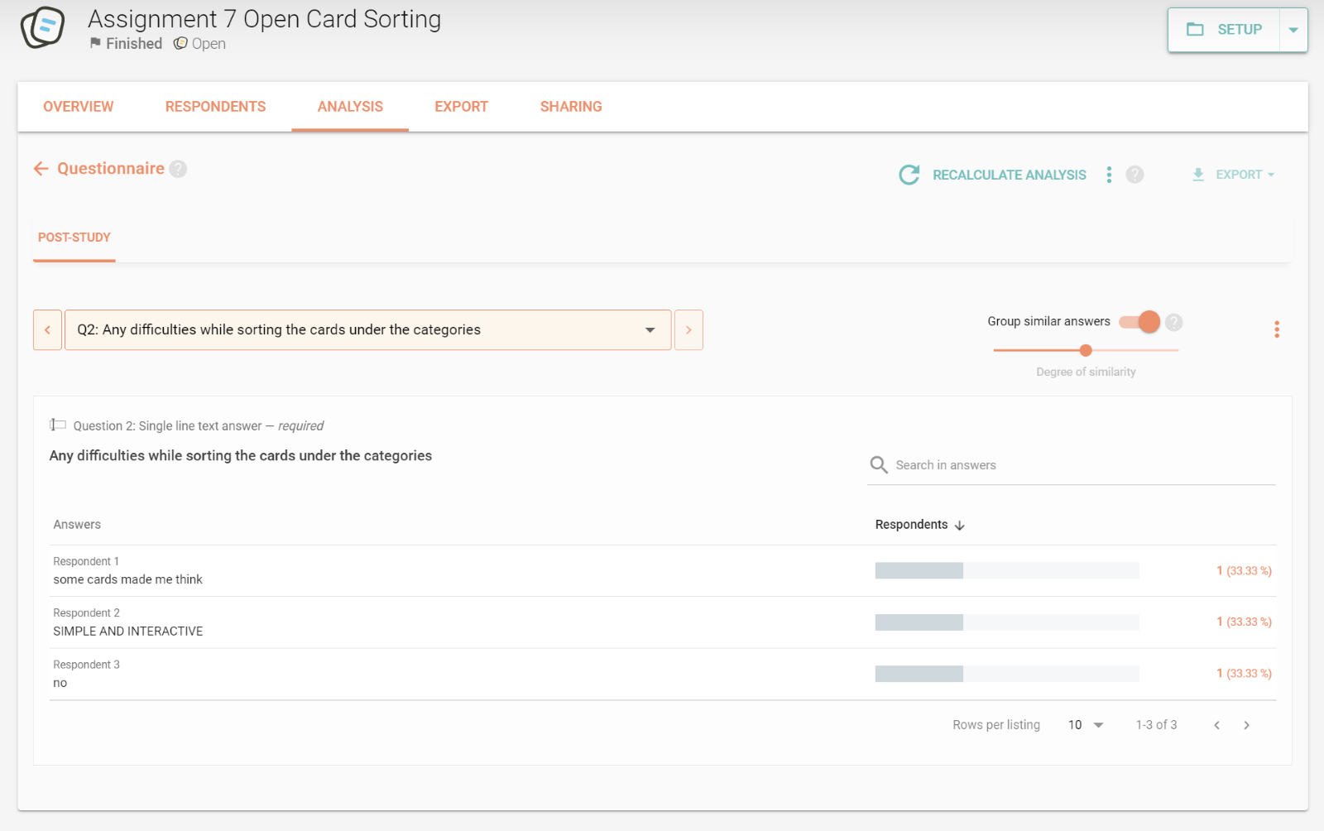
   6. The Respondent Centric Analysis is as follows, which shows the similarities of with among the sorting of all the respondents.
      1. 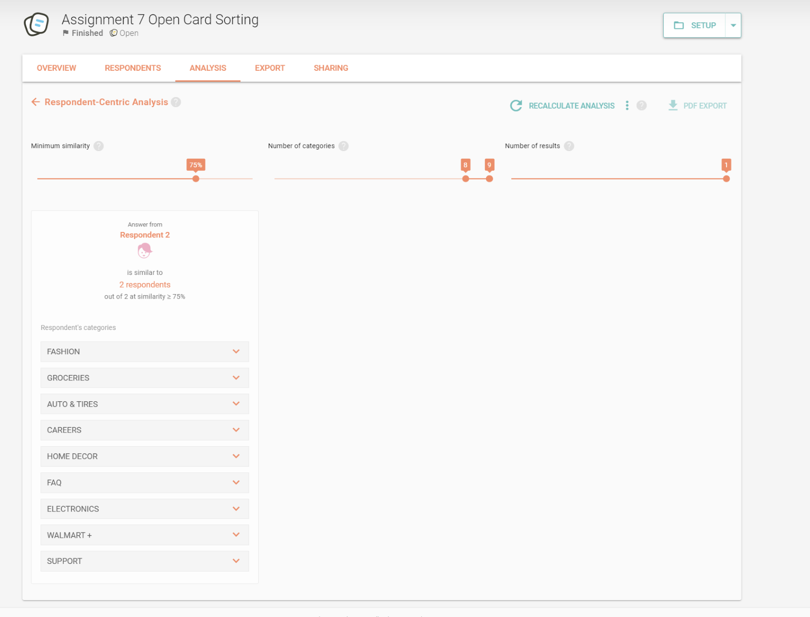
   7. The similarity matrix for the cards used in the open card sorting is as follows.
      1. 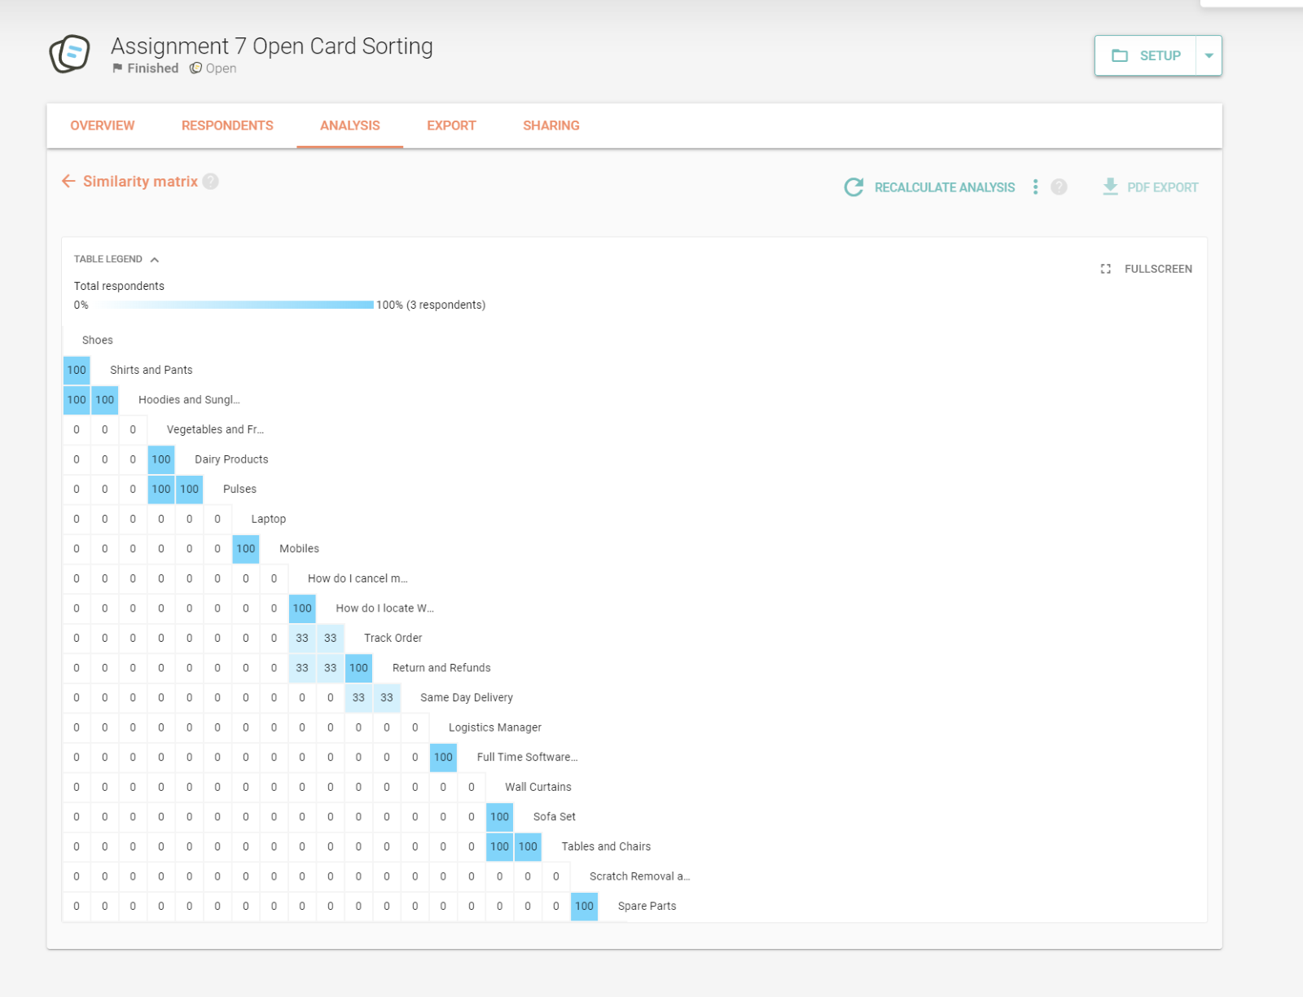
   8. The standardized grid for all the 20 cards used in the sorting process is as follows.
      1. 